

**Digital Marketing** Recommendations for Service Provider Cloud Hosters

**Microsoft Corporation**

**May 17th, 2012**

**Version 1.0**

Contents

Top 10 Recommendations 2

1) Use Clear and Consistent Messaging 3

Explanation 3

Speak Plainly! 3

Example 3

2) Clearly Say That You Sell the Cloud 4

Explanation 4

Shout It Out! 4

Example 5

3) Show Comparison Pricing 6

Explanation 6

Show Your Flexibility 6

Example 6

4) Use Social Media 7

Explanation 7

Go Social! 7

Example 7

5) Improve General Website Design / Layout 7

Explanation 8

The First Impression is Your Last 8

Example 9

6) Include Cloud Explanation Section 9

Explanation 9

Paint Pictures 9

Example 10

7) Review Search Engine Optimization (SEO) 10

Explanation 10

Get Discovered 10

Guidance Material 10

8) Search Engine Marketing (SEM) Campaign 12

Explanation 12

Promote Yourself 12

Guidance Material 13

9) Brand Your Business / Product 14

Explanation 14

Make Your Mark 14

Example 15

10) Include Client Testimonials 16

Explanation 16

Let Your Past Success Do the Talking 16

Example 17

Additional Recommendations 17

I. “Strut Your Staff” - Be Proud of Your Great Employees. 18

Explanation 18

II. “Implement Live Chat” - Be Accessible. 18

Explanation 18

III. “True Flexibility” - Incorporate Licensing Mobility into your Pricing Scheme. 18

Explanation 18

IV. “Communicate!” - Dialogue with your customers through email marketing. 19

Explanation 19

V. “Know Your Site Traffic” - Implement site analytics that provide real-time information regarding your website traffic. 19

Explanation 19

VI. “Reel Them In!” - Create effective landing pages for sales promotions. 19

# Top 10 Recommendations

|  |  |  |
| --- | --- | --- |
| 1) Use Clear and Consistent Messaging |  | Description: p1 |

## Explanation

### Speak Plainly!

**Use clear and consistent messaging on your website. For example, instead of discussing the Cloud’s “features,” talk in terms of clear benefits, cost savings, and functionality upgrades. Make potential customers clearly see the difference between your Cloud offering and other hosting options.**

* Present a **concise and compelling explanation** describing your Cloud offering that pulls your customers away from competitors and towards you.
* Generate **easy-to-read graphics, text, and videos**. Don’t overwhelm your audience with too much information. The more quickly and easily your customers can appreciate your service and take advantage of it, the better. Would you rather read, “Computing with the Cloud provides much more flexibility than other services…” Or would you rather simply see the word “FLEXIBLE” in all caps? You can always add more detailed captions or “Read more” sections if necessary (but even then, remember that less is more, and time is money).
* Comparison tables provide customers with a **quick-reference visual representation** of your superiority over competing products and service-providers. Wherever possible, use symbols (check mark or “thumbs up” icon) instead of words (“Yes” or “We’ve got it”). Also use colors to your advantage (green for yes, red for no, yellow for cautions or warnings, etc.).

## Example

The graphic below shows how clear and consistent messaging can be implemented on your homepage.

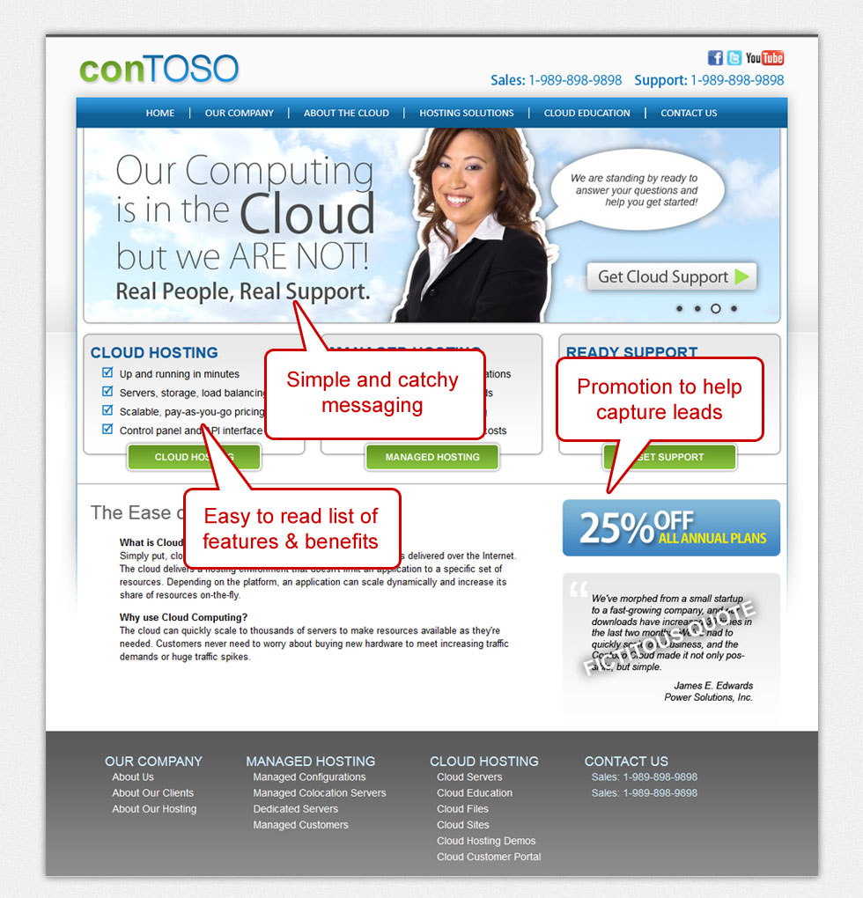

|  |  |  |
| --- | --- | --- |
| 2) Clearly Say That You Sell the Cloud |  |  |

## Explanation

### Shout It Out!

**Anticipate the terminology that your customers will most likely use in their internet searches. Even a quick glance at your homepage should leave no doubt that you offer Cloud services.**

* **Don’t shy away from using the word “Cloud”** throughout the text of your product descriptions so customers will know exactly what you’re offering. Instead of describing your product as a trendy new “virtual computing system,” simply offer “Cloud Hosting” or “Cloud Servers” in order to clearly affiliate yourself with this specific brand as opposed to a lesser imitator.

## Example

The graphic below shows how several instances of the term "Cloud" or "Cloud Hosting" can be placed on the homepage alone.

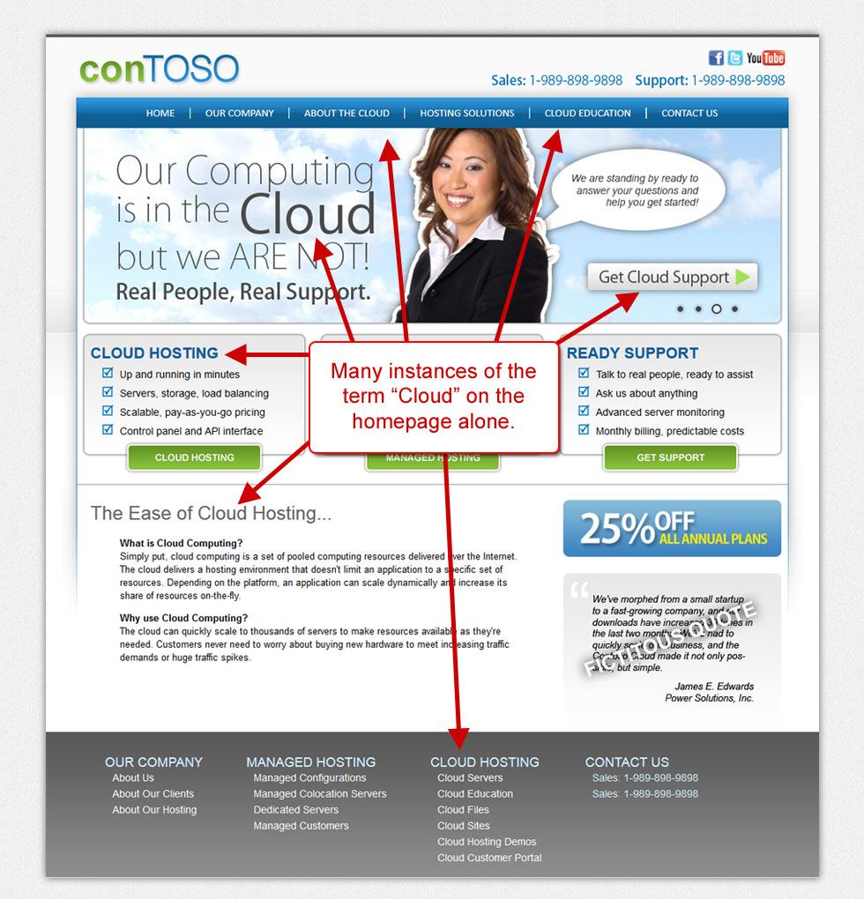

|  |  |  |
| --- | --- | --- |
| 3) Show Comparison Pricing |  |  |

## Explanation

### Show Your Flexibility

Show different pricing options for your Cloud services **so that your customers can clearly see and understand the differences**. When potential customers understand their options, it empowers them to decide the best solution for their unique needs and makes the Cloud more accessible to clients of diverse financial postures. Use graphic icons and/or colored tables to visually display the differences.

## Example

The graphic below shows how you can implement this recommendation on your website.

Click on the image to view the larger version.

***Example 1***

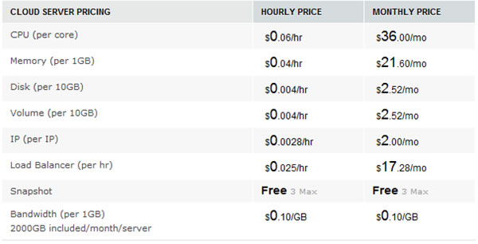

***Example 2***

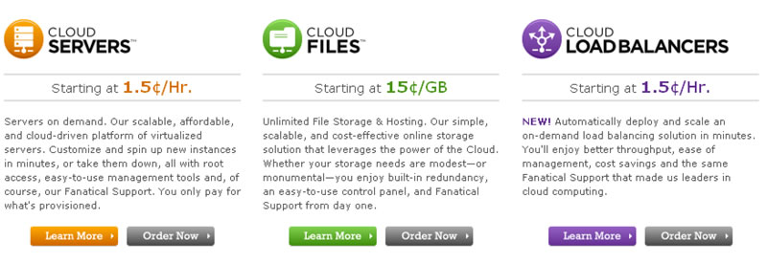

|  |  |  |
| --- | --- | --- |
| 4) Use Social Media |  |  |

## Explanation

### Go Social!

* **Create a blog** dedicated to Cloud. Include topics such as positive customer experiences, capabilities of the cloud, case studies, etc. A blog could help bump your search engine ranking ahead of your non-blogging competitor.   
    
  Create and maintain a **Twitter® account** and a **Facebook® page**.  Keep followers posted on news updates, features, quick tips, etc.  However, be sure to post regularly and keep your bulletin or microblog current, so followers will know that you are keeping up with the industry’s blazing speed.  Mobile device applications have helped to lessen the burden that frequent “tweeting” and Facebook posting can sometimes impose.
* **Search engines also pickup on keywords** used in blogs and Twitter accounts, so be sure to remember your SEO techniques and branding strategies.

## Example

Twitter for example is used by many companies to send updates and information quickly to their followers. By doing a search on www.Twitter.com for "cloud computing", you will see examples of what companies are "tweeting" about the Cloud.

|  |  |  |
| --- | --- | --- |
| 5) Improve General Website Design / Layout |  |  |

## Explanation

### The First Impression is Your Last

Has a stranger ever asked you out on a date based on your personality? Would you go to a job interview in your lawn-mowing clothes? No way! The same concept applies to websites. No matter how stellar your services may be, the Internet is still a visual place where businesses rise and fall on first impressions. You’ve got to **catch your customers’ eye and keep their attention** before you can ever hope to earn their patronage. Take pride in the the aesthetics of your website, so customers are more inclined to stay longer, continue reading, and get to know your product in more detail. There is perhaps no business investment with greater returns than a professional website that is well-designed and easy to navigate.

Here are a few useful tips on polishing up your online identity:

* **Develop well-written content with relevant information**, removing all extraneous, outdated content. If your budget allows, consider hiring a professional editor to keep your content in sync with your customer’s needs.
* **Make effective use of your website’s real estate**. Position your content strategically to enhance usability, accessibility, and intrigue.  Navigational tactics like promotion clickthroughs and teaser links can maximize general information consumption with minimal space.
* **Pay for professional graphics**. Never let your website feel like a business report or a research paper.  Choose dynamic and vibrant images that are relevant to the goals your customers will hope to achieve with the Cloud.
* **Discover the “Carewords” that will move your audience to take action.**  A link to the bland and leisurely world of “More Information” is far less tempting than an urgent, concrete, results-oriented invitation to “Sign Up In Minutes” or “Increase Profits Today” with a single click of the mouse.

## Example

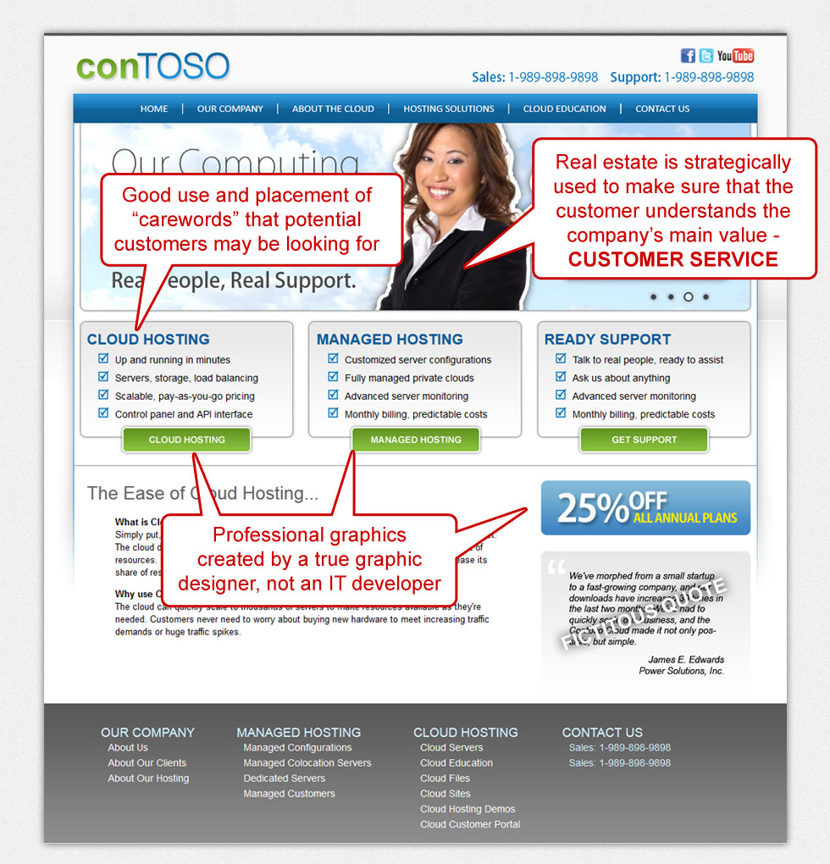

|  |  |  |
| --- | --- | --- |
| 6) Include Cloud Explanation Section |  |  |

## Explanation

### Paint Pictures

**Never leave your product to the customer’s imagination. Instead, make it immediately tangible. Create video tutorials and software tours that clearly demonstrate the utility, value, and simplicity of your Cloud solutions.**

* If done effectively, this educational approach gives you credibility and earns your customers’ trust.  These kinds of “teaser” demos prove your own mastery of the Cloud while peaking customers’ interest in the potential benefits they could reap from your services and expertise.
* Here’s a good example of an effective video promotion:   
  [Click Here to See the Video](http://www.microsoft.com/en-us/news/videos/videodetail.aspx?uuid=e7e0b759-70c5-48a5-9813-709a0873239e)

## Example

The video below is an example of a simple explanation of the features and benefits of cloud hosting.

[Click Here to See the Video](http://www.microsoft.com/en-us/news/videos/videodetail.aspx?uuid=e7e0b759-70c5-48a5-9813-709a0873239e)

|  |  |  |
| --- | --- | --- |
| 7) Review Search Engine Optimization (SEO) |  |  |

## Explanation

### Get Discovered

**Review your Search Engine Optimization (SEO) regularly to ensure that your search engine rankings continue to improve.**

* Put automated processes in place to constantly monitor your SEO standing.  Update your SEO strategies on a regular basis.
* Consider outsourcing this type of work if internal resources don’t yet allow you to keep this information current on your own.

## Guidance Material

* **Resource Website**  
  Microsoft’s SEO Toolkit is a good starting point to use when creating an effective keyword list. Once you have generated your list, you can strategically place these keywords throughout your website.  
    
  **Microsoft’s Free SEO Toolkit**

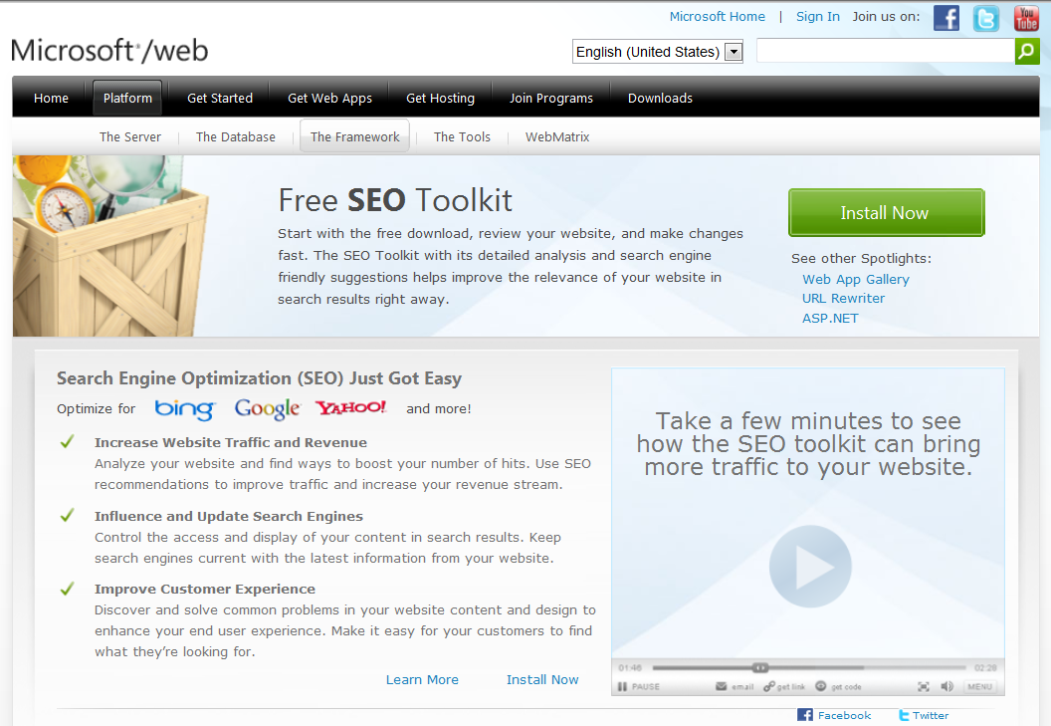

* Keyword List (Excel File)  
    
  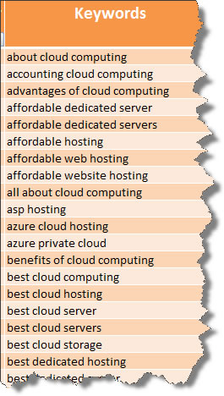

|  |  |  |
| --- | --- | --- |
| 8) Search Engine Marketing (SEM) Campaign |  |  |

## Explanation

### Promote Yourself

**Execute a Search Engine Marketing (SEM) campaign to promote your Cloud products and services.**

* You must actively monitor these campaigns to keep them cost effective.
* There are companies that you can partner with when executing these campaigns if you do not have internal resources to manage them.

## Guidance Material

**Resource Website**  
Microsoft’s SEO Toolkit is a good starting point to use when creating an effective keyword list. Once you have generated your list, you can leverage these keywords with your SEM campaigns.

**Microsoft’s Free SEO Toolkit**



[**Keyword List (Excel File)**](http://www.controlaltdesign.com/hyperv/images/GeneralCloudSEMKeywords_v1.xlsx)   
(for use with your SEM campaign)  
  
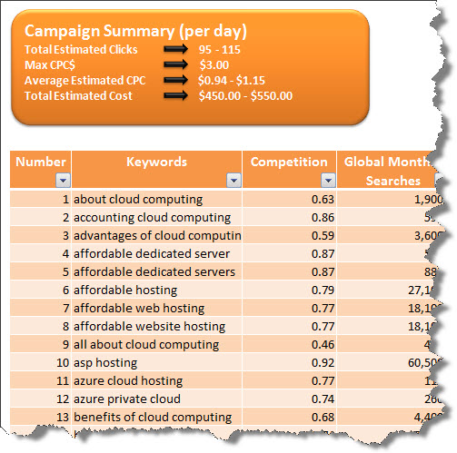

|  |  |  |
| --- | --- | --- |
| 9) Brand Your Business / Product |  |  |

## Explanation

### Make Your Mark

**Build a strong brand for your business and your product.**

* Select a “P” and focus on it to start to build your brand. Eventually, you can include the other ‘P’s as additional brand builders.
  + Whether you focus on pricing or benefits, your branding must be consistent throughout your website.
  + In April of 2010, Hubspot.com posted a useful article on its blog called **“6 Ways to Brand Your Business with Content.”** It’s a good resource for ways to increase brand recognition through site content: [Visit the website.](http://blog.hubspot.com/blog/tabid/6307/bid/5840/6-Ways-To-Brand-Your-Business-With-Content.aspx)
  + Here are some examples of focused branding:
    - Great Customer Support 
    - Experts in a specific market (e.g. government) 
  + Here are recommendations for other branding strategies to pursue:
    - Focusing on low prices (e.g. “We have the best pricing in the industry”) .
    - Differentiate your company as ONLY an enterprise cloud solution provider.

## Example

**See below of how the Sample Website brands "Customer Service"**

Website strategically designed to shout to the world, "Customer Focus is Our Priority"

* Friendly and inviting image of someone ready and willing to help.
* Catchy phrase of "Real People, Real Support"
* Link to a cloud support page on the website, making themselves very   
  accessible, not "in the clouds."

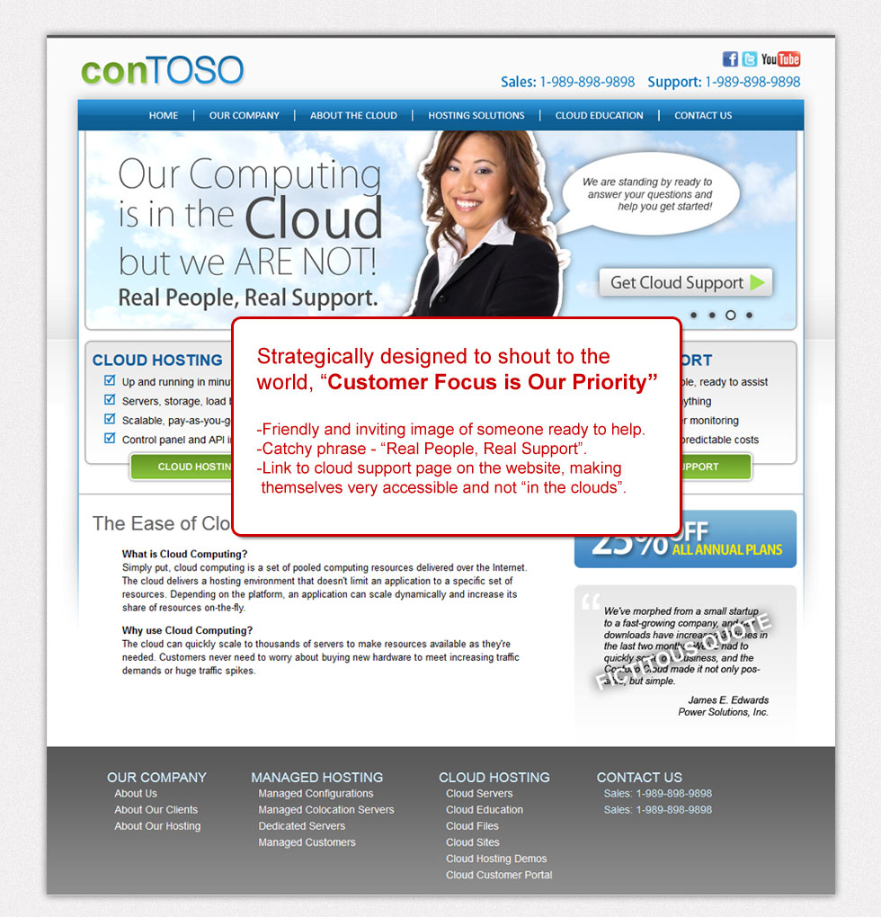

|  |  |  |
| --- | --- | --- |
| 10) Include Client Testimonials |  |  |

## Explanation

### Let Your Past Success Do the Talking

**Client testimonials are a great way to legitimize your claims and lend credence to the promises you make to potential customers.**

* Gather and prominently display testimonials from happy customers who have made successful use of your Cloud products in the past.
* Textual feedback can be collected fairly easily and featured on your website with little inconvenience to you or to the client providing the commentary.  Video testimonials require a bit more effort but can be even more persuasive to potential new clients.

## Example

Example of the use of testimonials on the Sample Website

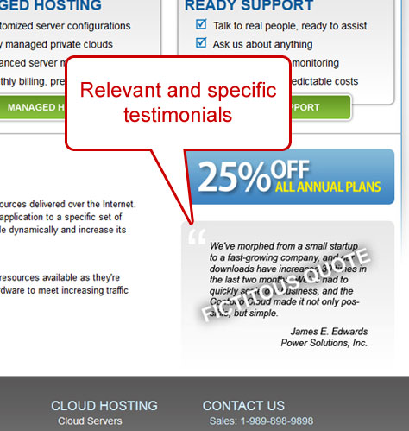

# Additional Recommendations

## I. “Strut Your Staff” - Be Proud of Your Great Employees.

## Explanation

* Although you want your customers to start computing in the Clouds, you want to assure them that your FEET, on the other hand, are firmly planted on the ground.  One way to humanize a digital, virtual, intangible product is to **feature your staff members** on your website.
* **Create a page dedicated solely to the “experts”** on your team. This will not only better establish your business as highly-qualified among industry competitors, but it will also add a bit of real “flesh and bone” to the otherwise completely virtual world of Cloud computing.
* **Pictures of your actual staff** (not stock photos of actors or models) will demystify your Cloud services  and reach out to potential customers on a more personal level.

### II. “Implement Live Chat” - Be Accessible.

## Explanation

**“Live Chat” is the latest innovation in effective customer service.  Particularly when offering a specialized product that can be intimidating to novices or lay-users, the personal feel of a live chat option can mean the difference between a customer’s decision to learn more or to move on to your competitor.**

* The Live Chat Option is an extra benefit to customers who may need instant assistance comprehending a particular topic.
* This solution provides the appearance of 24/7 customer service even if it is not utilized by your clients.
* Live Chat makes your website feel more modern, more technically savvy, and more in tune with the latest communication media.  It especially appeals to the burgeoning generation of users who are hard-wired against the days of 800-numbers and automated phone menus.
* These days, no business in the information technology industry can afford to ignore the recent explosion of social media outlets.  As the internet has grown bigger and more complex, social media have countered with ever-increasing accessibility. Mass communication has never been faster, easier, or more wide-spread.  Take full advantage of these new and exciting vehicles of maximum exposure.

## III. “True Flexibility” - Incorporate Licensing Mobility into your Pricing Scheme.

## Explanation

* By July 1, 2011, every pricing model for Hyper-VTM Service Providers will have gone through the Service Provider Licensing Agreement (SPLA). This new agreement will provide more flexibility to customers once Microsoft introduces licensing mobility.
* "Each customer is approaching the cloud at their own pace. That’s why it’s important that we ***offer them the flexibility that license mobility provides***. This new licensing ‘right’ helps separate the purchase decision from the decision of where the customer deploys the license." [Read the Extended Explanation.](http://www.microsoft.com/licensing/about-licensing/value-of-volume-licensing.aspx#tab=4)

## IV. “Communicate!” - Dialogue with your customers through email marketing.

## Explanation

* Give customers personalized attention with email updates. This is an effective way to keep your customers informed about promotions, news updates, blog postings, and other recent developments.
* Remember that email marketing can sometimes be annoying. These days, people are ever-vigilant with their spam filters and email security settings. However, if your messages contain useful or profitable information while respecting your clients’ time and privacy, then they are far less likely to land in the junk mail folder.
* [Constant contact](http://www.constantcontact.com) is a good marketing service to use for this effort.

## V. “Know Your Site Traffic” - Implement site analytics that provide real-time information regarding your website traffic.

## Explanation

* Don’t leave the success of your website to chance. Analyze its performance and respond quickly when user trends suggest that adjustments should be made.

## VI. “Reel Them In!” - Create effective landing pages for sales promotions.

* Landing pages can shine an attention-grabbing spotlight on particular products or benefits you seek to highlight or promote.
* This technique is very effective when used in combination with the SEM recommendation.
* Landing pages also allow you to quickly gauge the rate at which your promotion converts to sales.